**NATIONAL INSTITUTE OF TECHNOLOGY**

**KURUKSHETRA**



**PRACTICAL FILE**

**SUBJECT :-** **Programming Using Python**

**BRANCH :- CS-A-01**

**ROLL NO :- 12112003**

**Submitted to:-**

**Shweta Pandey mam**

**Submitted by:-**

**Priyanshu maurya**

**Experiment-7**

1. Write a Python program to multiplies all the items in a list.

li=*list*(eval(input("ENter some integers(separated by commas) : ")))

ans=1

for i in li:

    ans=ans*i

print("Multiplication of all numbers in the list is :",ans)

OUTPUT

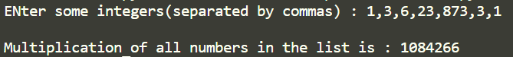

1. Write a Python program to count the number of strings where the string length is 2 or more and the first and last character are same from a given list of strings.   
   Sample List : ['abc', 'xyz', 'aba', '1221'] Expected Result : 2

li=*list*(eval(input("ENter some strings(separated by commas) : ")))

ans=0

for i in li:

    if len(i)>1 and i[0]==i[-1]:

        ans+=1

print("NO of such strings is",ans)

OUTPUT

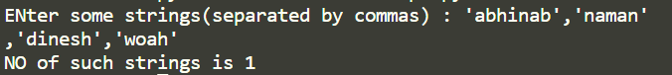

1. Write a Python function that takes two lists and returns True if they have at least one common member.

*def* common(*a*,*b*):

    for i in a:

        if i in b:

            return True

    return False

*def* main():

    a=*list*(eval(input("ENter some integers(separated by commas) : ")))

    b=*list*(eval(input("ENter some integers(separated by commas) : ")))

    if common(a,b):

        print("There is at least one element common in given lists.")

    else:

        print("There no element common in given lists.")

if __name__=="__main__":

    main()

OUTPUT

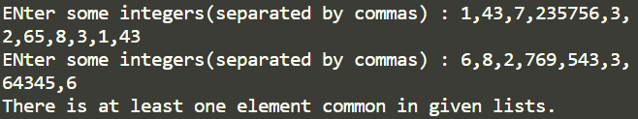

1. Write a Python program to generate and print a list of first and last 5 elements where the values are square of numbers between 1 and 30 (both included).
2. Write a python program to check whether two lists are circularly identical.

*def* circular_identical(*a*,*b*):

    if len(a)!=len(b):

        return False

*# method 1(python is love)*

    for i in range(len(a)):

        first=a.pop(0)

        a.append(first)

        if a==b:

            return True

    return False

*def* main():

    a=*list*(eval(input("ENter some integers(separated by commas) : ")))

    b=*list*(eval(input("ENter some integers(separated by commas) : ")))

    if circular_identical(a,b):

        print("Given 2 lists are circlular identical.")

    else:

        print("Given 2 lists are NOT circlular identical.")

if __name__=="__main__":

    main()

OUTPUT

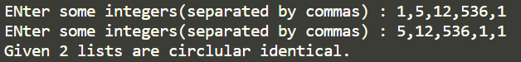

1. Write a Python program to convert a pair of values into a sorted unique array.

li=*list*(eval(input("Enter values in pair( enclosed in parenthesis and separted by commas) : ")))

s=*set*()

for i in li:

    for j in i:

        s.add(j)

ans=*list*(sorted(s))

print(ans)

OUTPUT

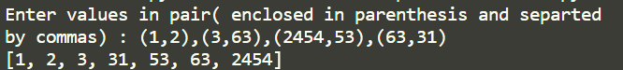

1. Write a Python program to convert list to list of dictionaries.   
   Sample lists: ["Black", "Red", "Maroon", "Yellow"], ["#000000", "#FF0000", "#800000", "#FFFF00"]  
   Expected Output: [{'color_name': 'Black', 'color_code': '#000000'}, {'color_name': 'Red', 'color_code': '#FF0000'}, {'color_name': 'Maroon', 'color_code': '#800000'}, {'color_name': 'Yellow', 'color_code': '#FFFF00'}]

names = *list*(eval(input("ENter some integers(separated by commas) : ")))

codes = *list*(eval(input("ENter some integers(separated by commas) : ")))

colors_list = [*dict*(*color_name*=x, *color_code*=y) for (x,y) in zip(names, codes)]

print(colors_list)

OUTPUT

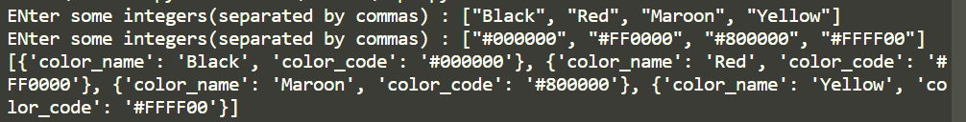

1. Write a Python program to find a tuple, the smallest second index value from a list of tuples.

a=*list*(eval(input("Enter tuples ( enclosed in () and separated by , ) : ")))

ind=0

for i in range(1,len(a)):

    if a[i][1]<a[ind][1]:

        ind=i

print(a[ind])

OUTPUT



1. Write a Python program to check if all dictionaries in a list are empty or not.   
   Sample list : [{},{},{}]  
   Return value : True  
   Sample list : [{1,2},{},{}]  
   Return value : False

a=*list*(eval(input("Enter dictionaries (enclosed in curly braces in key value pairs separated by commas) :")))

flag=1

for i in a:

    if len(a)!=0:

        flag=0

        break

*# print(i)*

if flag:

    print("All dictionaries in the given list are empty.")

else:

    print("At least one dictionaries in the given list is not empty.")

OUTPUT

